

Features Specification
Milksafe 5 Port Reader
Ⓘ This document describes the high level features of the 5-channel incubator.

Questions to be answered

ChrHansen
✓ | Do users select “Read” or “Incubate and read” to run the test. Or does this depend on the test type and comes from the test type cloud configuration? | Both options are available in settings (like we have for the DRC); If only “Incubate and read” is selected, the machine will identify the test type through QR code and decide incubation time and Temp.
✓ | Do we still support comments? | The user can comment in the history. They comment on the entire Group, not an individual test record. When such a group is opened in the cloud, the comment is displayed for any of the individual test records details. A little icon or similar indicates in the list of grouped test records there is a comment.
✓ | Do we support OperatorID and Route scanning by using an external device? | Yes. Scanning works similarly to the Desktop Reader.  Both operator id and route for both logged in and out
✓ | Are the test records synced for a particular test account like in mobile apps? This allows for test records synchronization after a factory reset. But ideally requires separate accounts for every device. | Same behavior as DRC. We send the test records to the cloud but we do not download it to the device.
✓ | Can the user change the annotation for a test in its test detail? | No. Annotation should not be possible to change on the device.
✓ | Should the device be able to print a verification result? | Yes. The machine can print both - individual test results (the same format as the current DRC) and grouped test results;
✓ | Can you provide us with design guidelines / color palettes for the Novonesis brand? | The design is similar to the current mobile applications and the DRC, Chr. Hansen inspired design.
✓ | Aflatoxin test type specification needs to be cleared out | Aflatoxin workflow will be similar to the current Desktop Reader.
✓ | Do we ignore the test type temperature in the test type and just let the user set the temperature manually on the device? | The temperature is set for the entire device, all 5 channel, and can be set to 40 or 50 degrees. Or turned off completely.
✓ | Do we take the incubation time from the test type configuration only or we allow the user to set the incubation time manually on the device? | Same answer as above, the user should not decide incubation time. This is ruled by the test type.
✓ | Does the device have a microswitch on and off setting like in DRC? | Yes, we want the possibility to switch on and off.

Bioeasy
✓ | Are we able to measure the light intensity on this device for verifications? If yes, where do we read this in the bluetooth response? | Yes. We can measure the light intensity as one number
✓ | What dimensions is the device display? In pixels. | 800*480 in pixels, 155mm*86mm
✓ | Are there any technical requirements we should take into consideration when building the design for you? Meaning operating system limitations, UI guidelines? We assume the UI will be very similar to Desktop reader in the way the user interacts with it. | The 5 port device operating system is similar to the current Desktop Reader. Similar guidelines apply.
✓ | What are your options on how to handle the translations of the device texts? For mobile and web, we use Tolgee.io that allows us to keep the texts and translations in one place, translate using AI etc.  Tolgee allows exports to generic formats like XLIFF, Structured JSON, Gettext (.po), .properties, Flat YAML, Structured YAML, CSV or XLSX. | Tolgee can be used ad kiwi.li@bioeasy.com confirmed the exported files can be converted to the 5 port reader digestible format.
✓ | DRC does not know the users GPS location and uploads a placeholder location to the cloud. Will this new device be able to upload the correct location to the cloud? | The 5 port reader does not know the user location. Empty location should be uploaded to the could as with the DRC.
✓ | Are we able to detect the cassette insertion every time?  Do we rely on the microswitch only or does the device also have the ability to detect the cassette based on the camera or similar? We are trying to see if we can rely on the cassette detection capability of the device? | Only insertion can be detected. Removing the cassette can not be reliably detected.

Initial Device setup
- Language selection
- Internet connection - wifi, ethernet or stay offline
- Date and time setup - including timezone
- Screen brightness and sound - on/off

Internet connection
- Wifi connection with password
- Ethernet connection
- No connection also allowed

Sign In to Cloud
- Only sign in, account creation outside of the reader’s SW
- Ability to skip and continue as anonymous

Home page
- Ability to navigate to these sections
  - Run Test
  - Tests history - this should display Test records and Control records, Verification Records have a different format and should be displayed separately
  - Controls (positive and animal) history (combined with test history)
  - Settings
- The most used sections are Run Test, Tests history and Settings
- Device incubator temperature, time of the day and when connected to the internet, the symbol should be visible on the screen (unless user disables incubation in the settings).
- Front screen notification if the number of passed tests since the last verification is above the set threshold - 250 tests.
  - Add an info bubble to the web to explain the threshold is 250

Run Tests

Test configuration pop up
- Test slots should be permanently visible in home screen - with option to fill in test information, which should appear as a button, and once clicked the filling in sections for operator ID and sample ID will pop-up, as well as options to run a normal test, a positive control or an animal control. For strip test a drop down menu should appear for the user to select the test type. If the strip to be tested is Afla, the options for Afla M1 batch calibration curves should also appear. If the user has only selected FAST tests from settings or clouds, no test selection options should appear (the test is identified by the QR code)
- User inserts the cassette into the reader’s channel, pop up appears instantly
- The reader reads the QR code on a cassette and prefills the test type based on the QR
  - If the test type is not enabled for the user’s site, or not enabled in the settings for an anonymous user, show a warning message instead of this pop up
  - If QR scanning is not enabled in the Settings, the QR is not scanned and the user selects the test type manually
- The user can choose if they want to read only or read and incubate. Test strips never incubate. Read the test type cassette type form the test, and if it is a strip, do not display the “`Read and incubate” button
- If the first test is (positive OR invalid) AND (it was incubated), repeat the incubation for 2 more minutes and judge the result based on the repeated reading. This applies to normal tests only, not on controls
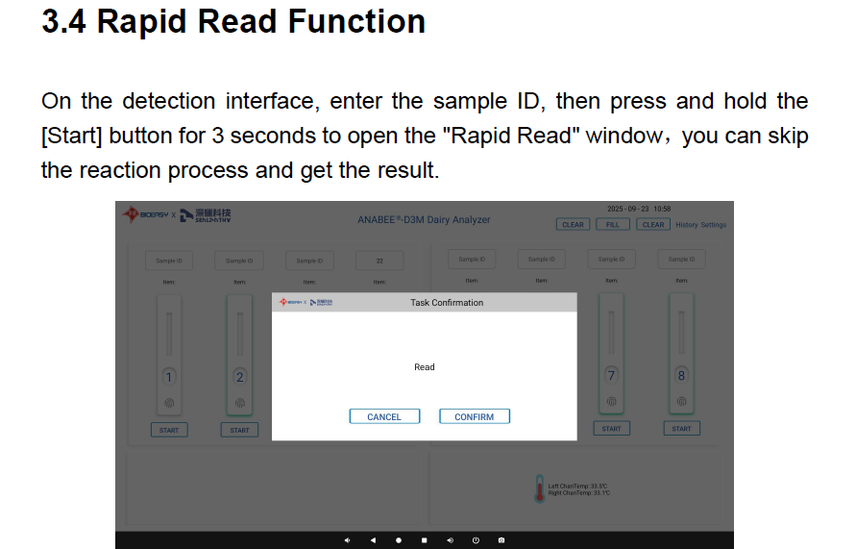

5 tests screen
- Display 5 channels on one screen
- Ability to run a confirmation flow for every channel separately
  - Confirmation flow is always run in the same channel
- Display individual substance results - positive or negative, not substance numbers -
- Display incubation time out
- The user is able to interrupt the incubation. The cassette needs to be removed manually then not to spill potentially positive milk instead of the machine “spitting it out”.

Confirmation flow
- User is able to run up to 3 tests in the same channel as part of the same test group
- The overall test group results are calculated the same as within the current mobile apps and desktop reader
- Different buttons displayed under the cassette image depending on the confirmation flow state

Tests history
- Displays history of test groups performed under this user account - Clarify with Bioeasy.
- Test groups are synced to the cloud and also cached in the reader
- When there is no internet connection, test groups results are cached and uploaded later when internet connection is obtained
- Tests displayed within their test groups, not only like a sequence of individual tests
- Channel number displayed for a test. This is cached in the reader, not synced with backend
- The history only displays the tests performed on this device

Tests export and printing
- Test groups can be exported both individually and as whole to:
  - Excel
  - CSV
  - LIMS? Do we export to LIMS here? YES
- Individual test results can be printed in the same format as the desktop reader

Individual test detail view
- A detail view can be displayed for an individual test
- The view contains this data similar to desktop reader:
  - Test result
  - Test type
  - Date
  - User
  - Operator ID
  - Route
  - Upload status - synced, not synced
  - Measured substances and values
  - Port number

Verification flow
Contains:
- Ratio measured
- Temperature measuring using a thermometer
- Light intensity

- The user can choose between a verification at 40 or 50 degrees Celsius.
- No test type is selected for verification and no test type is uploaded to the backend.
- For temperature, there is a 2 degree tolerance to pass the verification.
- The verification result can be printed.

The machine only has one scanner (that moves horizontally between the slots) and one heating plate. This means we do not need to perform a verification for every slot separately. We can just perform the verification in the first slot always.

Verification history
Displays a history of verifications done on this device.
The device uploads the verification to BE but also caches them locally.
When the device is reset, the locally stored verifications are lost. They remain in the cloud. This is a similar functionality to how test records are uploaded but never downloaded.

Settings

Password protected settings:
- QR scanning
- Micro Switch
- Verification threshold
- Test types
- Milksafe Cloud login
- Date and time
- Language
- Software Update
- FActory reset
- Temperature
- Verification history
- Internet connection

Not protected by password:
- Run verification
- Load Quant curve
- About

- Select language
  - Default is English
- Test types
  - Allows to enable or disable certain test types
  - For logged in users, this is configured on cloud and this setting is view only
  - Anonymous users can enable or disable all test types for this device
- QR scanning toggle
  - When turned off, QR is not scanned from the cassette when inserted into the channel
- Verification Settings
  - Local setting for number of tests since last verification to label a device as outstanding a verification
- Connect to internet
  - Wifi
  - Ethernet cable
- Printer setup Enable or disable
- Comment setup Yes or No
- Route (Sample ID) On and off
- Operator ID On and off
- Incubator On and off
- Microswitch On and off
- Lims On and off
- Sound On and off
- Date and time
  - Set the date, time and timezone for the device
  - Default to the UTC timezone
  - Include the time zone here and upload all the dates to the cloud with timezone data!
- Milksafe cloud
  - Username and password
  - Ability to logout
- Software update
  - Usb update - requires a zip file containing the unchunked firmware
  - Internet update - connects to the new chunking firmware endpoint /v2/Firmware/DesktopReader/latest and download the chunked firmware update
  - Factory reset - password protected
- About
  - Contains similar

Anonymous (not signed in) user features
The user can also use the device without being signed in.
Anonymous test records are uploaded with obfuscated data (no route, operator id and user name) to the Anonymous Data site.
When the user logs in, the cached anonymous data is assigned to their account and reuploaded to their site.

Functional features

Background request
- The device attempts to download the test types and their configuration for a particular site every 5 minutes. For an anonymous user, it fetches all test types. This ensures the test type changes made in the cloud by the admin are propagated to the device.
- If there are test records not uploaded to the cloud, the device attempts to reupload them every 5 minutes.

Device Temperature
Upon turning on, the default incubation temperature should be 50 degrees Celcius;
The device incubation temperature is set manually by the user. The device temperature is NOT set based on the test type configuration (as opposed to Desktop and Truck reader).

The user can manually set the temperature to 40 or 50 degrees Celsius.

When the user inserts the cassette and the reader reads the test type from its QR code, the reader checks the current device temperature is within a 2 degrees range of the test type configuration temperature.

If the device is out of this range, a warning message is displayed and the user can not proceed to test the milk. (unless the temperature enters the desired range)

Aflatoxin test type
The Aflatoxin test flow will be similar to the current Desktop Reader in terms of UI.

The calibration curve will be loaded to the device using an ID chip (as with the Desktop Reader) or QR code scanning.

